**SSN COLLEGE OF ENGINEERING**

**KALAVAKKAM - 603110**

**INTERNALLY FUNDED STUDENT PROJECT – 2019**

**Project Title**

**IOT BASED AIR POLLUTION MONITORING AND FORECASTING SYSTEM**

**Students:**

Srinithyee S K,

Venkataraman N ,

Vishakan S,

II year,

Department of Computer Science and Engineering

**Project Guides:**

Dr. R. Priyadharsini

Associate Professor,

Department of Computer Science and Engineering

Ms. S. Manisha

Assistant Professor,

Department of Computer Science and Engineering

**Budget: *Rs.21250**

**Project Duration: 12 Months**

Signature of the Project Students Signature of the Project Guide(s)

Signature of the HOD

**1.Project title**

**IOT BASED AIR POLLUTION MONITORING AND FORECASTING SYSTEM**

**2. Broad Subject:**

Sensors, Predictive Analysis, Internet of Things, Machine Learning, Regression, Statistics, Data Analysis

**3. Project Duration:**

12 Months (July 2019-July 2020)

**4. Budget:**

21250 INR

**5. Project Summary:**

Air pollution is the largest environmental and public health challenge in the world today. Air pollution leads to adverse effects on Human health, climate and ecosystem. Air is getting polluted because of release of Toxic gases by industries, vehicular emissions and increased concentration of harmful gases and particulate matter in the atmosphere. Particulate matter is one of the most important parameters having the significant contribution to the increase in air pollution. This creates a need for measurement and analysis of real-time air quality monitoring so that appropriate decisions can be taken in a timely period. Internet of Things is nowadays finding profound use in each and every sector, plays a key role in our air quality monitoring system too. Internet of Things converging with cloud computing offers a novel technique for better management of data coming from different sensors, collected and transmitted by Raspberry pi. The system can be laid out in a large number in monitoring area to form monitoring sensor network. Besides the functions of conventional air automatic monitoring system, it also exhibits the function of forecasting development trend of air pollution within a certain time range by analyzing the data obtained by front-end perception system according to neural network technology.Targeted emergency disposal measures can be taken to minimize losses in practical application.

**6. Keywords:**

Internet of Things, Air Quality Monitoring, Arduino Uno, Raspberry Pi, Cloud Computing, Neural Network Technology, Data Science, Machine Learning, Statistics

**7. Objectives:**

Our project aims at the following objectives:

* To implement a system for measuring air quality and air pollution details and display the necessary details, and also to predict air quality in the future.
* The sensors are being used for detecting different environmental parameters like particulate matter, Carbon Monoxide, Carbon Dioxide, Temperature, Humidity and Pressure. The sensors are connected to Arduino Board and Raspberry Pi. The Raspberry Pi is interfaced with Arduino Uno through USB cable. The data sensed by the sensors are continuously transmitted through Raspberry Pi to the cloud over the internet because of its good network connectivity.
* The client can access the data that is being displayed on the dashboard by using the device id but the client will be not able to do any modification to the data received.
* According to the relationship between current pollutant concentration and the pollutant concentration in the past 24 hours, a 24 hours’ prediction network is established. The average pollutant concentration is adopted to train network and then predict the pollutant concentration per hour in the next 24 hours.

**8. Introduction:**

With the rapid development of economy, chemical industrial park construction and production activity are increasingly frequent, leading to increasing probability of environmental pollution accidents, especially air pollution accident. Affected by meteorological and geographical conditions, air pollution will be highly clustered in a short time after happening, causing great harm or even extreme destruction to both human and environment. So it is particularly important to set up a real-time air pollution monitoring system.To overcome defects of traditional monitoring system and detection methods and reduce test cost, this project implements a method combining IOT technology with environment monitoring. By replacing monitoring equipment in traditional empirical analysis with sensor network in IOC technology, through which inexpensive sensors can be laid out flexibly in the whole area to monitor omni-directionally to provide data support for prediction.

**9. Definition of the problem:**

In light of this problem we propose to build a system to collect data using sensors of various parameters of air over a period of time, and analyse the collected data to develop an algorithm to predict the air pollution levels for a specified time in the future. This way, a person can better understand his environment and be prepared with necessary precautionary measures well ahead in time, and also understand the levels of air pollution around him/her, which will guide him to being more responsible with maintaining his/her environment in a better way. The main agenda is to monitor and make predictions of air pollution levels in its surroundings.

**10. Review of the status of Research and Development in the subject:**

**10.1 National Status**

The Government of India has collected datasets related to air quality from different areas. There is also an app available for viewing the National Air Quality Index(AQI) published by the CPCB. Real time air quality index is measured using parameters like SO2, NO2 and particulate matter across various stations in India. These datasets are available for public disposal under the *data.gov.in* website. There has been significant development in both large scale(by the meteorological department of India) as well as by small-scale projects involving air quality sensing, and apps made by individuals across the nation.

More specific – Akshata Tapshetti’s paper – Uses cloud and Iot to monitor Real-Time Air pollution rate (basic mq sensors) ,Making it cost efficient and faster ,Since no data is stored in intermediate stage.

Also accompanies an android app to veiw graphical rates of different gases at real time.

**10.2 International Status**

There is extensive development internationally, by organisations such as the UN Environment, which has implemented the Global Environment Monitoring System for Air(GEMS/Air).

Websites like *waqi.info* (World’s Air Pollution Index) gives an estimate value of the local air quality index in different parts of the world. Proprietary air quality monitoring systems have been built and used by various industries across the world, according to their own needs and specifications. The public though, has to rely mostly on information provided by the government and by organisations like AccuWeather, and Weather.com. Few sensing systems are available commercially, but they are mostly too technical in nature and not budget-friendly for the perusal of the common individual. Government data is an average estimate over a particular locality and may or may not be the actual value in a specified locality.

More specific : On Dr.Lui Sha’s paper – mainly deals with aspect of money spent on Health expenditures by their Govt. On basis of age and sex.Provided most of the chronic dieseases spread through air. It is essential to monitor then (ozone and smoke sensors) and try to keep them under control

**11. Novelty importance of the proposed project:**

The IOT-based air pollution sensor and forecasting system is a necessity in today’s world, which has become plagued with increasing levels of air pollution, which causes a heavy toll to the Earth and its lifeforms. A primary step in reducing air pollution is to first understand how bad the situation is, and be aware of the extent to which the air is polluted around us. Thus, we need a sensing system to tell us this in an understandable manner. The forecast system is also necessary because we need to know if there will be any improvement/deterioration of the quality of air in the future, so that we could take/alter preventive and control measures to make better the quality of air around ourselves.

**12. Patent details:**

This particular system of monitoring & forecast is yet to be patented.

**13. Work plan and Detailed technical information:**

The necessary sensors will be appropriately connected with the Arduino Uno board, which is then connected to the Raspberry Pi for transferring the data from the sensors into the local storage and for analysis. The Raspberry Pi is configured with Ubuntu OS and most of the programming part required for the data analysis is done locally in the Pi’s system. The work schedule will consist of first implementing the sensor circuitry on the Arduino board and using necessary libraries to get meaningful data from the sensors. The next phase would consist of linking the Raspberry Pi with the Arduino board so that the output from the circuitry is processed and stored as per requirements in the local storage of the Pi. The data would also be sent to a cloud storage for access from any other system, for program development purposes. When a large enough data set is obtained, predictive analysis phase begins and the development of a suitable algorithm to forecast future air quality information would be made possible with statistical, mathematical and machine learning concepts. Most of the programming work is done using Python, as it can support huge datasets and is also an appropriate programming language for performing machine learning and data science algorithms, since it has very useful libraries like NumPy, MatPlotLib, TensorFlow and SciPy.

**13.1 Methodology:**

The output data from the sensors is sent to the Pi where it is locally stored and also sent to the cloud for global wireless access. Data has to be collected over a certain period of time before valid and reasonable predictions can be made. Once sufficient data has been collected, we use programming constructs defined using Python (making use of the Pandas, SciPy and NumPy libraries for data analysis and predictions)

The predicted values can then be stored in the cloud and then verified whether the values have a tolerable range of error and the predictive model can be modified accordingly.

The prediction model can be made better with increase in data set, so our idea is that the model will get better overtime and give better results going further down the line.

Additionally, we can use the dataset to plot graphs with various parameters (using MatPlotLib in Python) for further detailed studies. One can know whether a particular place has seen any improvement/decline in air quality, and the variation of air quality parameters over a given period of time. Seasonal analysis, hourly and monthly analysis can be done over a given place.

If needed, location based analysis can also be done by comparing datasets in two or more places where the data was measured.

FIELD SENSOR NETWORK

PERCEPTION

DATA TRANSMISSION

CLOUD / LOCAL HOST

**14. Time schedule of activities giving milestones:**

|  |  |  |  |  |  |
| --- | --- | --- | --- | --- | --- |
| **S.No** | **Activity** | **Months** | | | |
| **1-3** | **4-6** | **7-9** | **10-12** |
| **1.** | **Literature Survey & collecting data** | **aaa** |  |  |  |
| **2.** | **Construction of System for monitoring air pollution.** |  | **aaa** | **aaa** |  |
| **3.** | **Predictive Analysis** |  |  | **aaa** | **aaa** |
| **4.** | **Results and Documentation** |  |  |  | **Aaa** |

**14.1 Time Schedule of Activities through Bar Chart:**

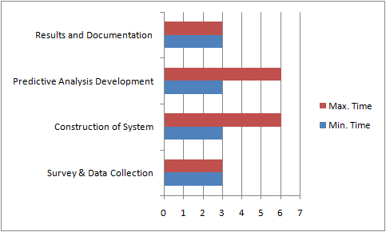

**15. Deliverables:**

* Reliable information on local air quality levels.
* Fairly accurate information on air quality levels in the future in the surrounding environment.
* Dataset consisting of various air quality parameters in a particular area for a long period of time, captured in real-time.
* Instantaneous air quality levels.
* Prediction system works in any kind of environment, be it industrial, outdoor, indoor, etc.

**16. Target beneficiaries of the proposed work:**

Target beneficiaries of this project range from the common man to large industrial organisations, governments and environmental organisations. A common man living in a very polluted space like Delhi can know the air quality inside his/her house, and an environmental organisation trying to survey/maintain/improve an area can make use of this system to implement/improvise routines for air quality improvement. The same goes for governments. Industries dealing with exhaust in the form of smoke and industries dealing with chemicals can monitor the air quality levels inside and outside of their operating plants, and keep the pollution levels in check.

**17. Suggested plan of action for utilization of research outcome expected from the project:**

**Project preparation for submission to external funding:**

This project can be submitted for external funding or can be further developed in collaboration with environmental NGOs, weather forecast agencies, meteorological department of the government to increase the accuracy of prediction by using high-precision sensors, better algorithms, and also add more functionality to the proposed system. It is of good use to these organizations and other industries for air quality control and monitoring.

**18. References:**

[1] Chen Xiaojun, Liu Xianpeng and Xu Peng, “IOT- Based Air Pollution Monitoring and Forecasting System”

[2] Somansh Kumar and Ashish Ahuja, “Air Quality Monitoring System Based on IoT using Raspberry Pi”

[3] Gagan Parmar, Sagar Lakhani and Manju K. Chattopadhyay, “An IoT Based Low Cost Air Pollution Monitoring System”

[4] Akshata Tapashetti and Divya Vegiraju, “IoT-Enabled Air Quality Monitoring Device-A Low

CostSmart Health Solution”,

[5] LuiSha ,SathishGopalakrishnan, XueLiu, etal.Cyber-physicalsystems:a newfrontier. Proceedings of

2008 IEEE InternationalConference on Sensor Networks, Ubiquitous, and Trustworthy Computing

[6] Gouldson A, Morton A, Pollard S J T. Better environmental regulation –contributions from risk -

based decision -making.

[7] Upton, Eben, and Gareth Halfacree. Raspberry Pi user guide. John Wiley & Sons, 2014.

**19. List of facilities and equipment available with department for the project:**

The computer science department at SSN is sufficiently equipped with computers and campus-round WiFi connectivity. The college also has a library that has many books and papers on related topics, for research and further studies required for the development of the proposed model.

**20. Budget estimation:**

|  |  |  |  |
| --- | --- | --- | --- |
| **Component** | **Quantity** | **Price per unit** | **Price net** |
| **MQ135(Air Quality) sensor** | 1 | 200 | 200 |
| **MQ2(Smoke) sensor** | 1 | 300 | 300 |
| **MQ7(Carbon Monoxide) sensor** | 1 | 300 | 300 |
| **MG811(Carbon Dioxide)sensor** | 1 | 4000 | 4000 |
| **Raspberry Pi 3** | 1 | 3000 | 3000 |
| **MQ138(Benzene & Toluene)** | 1 | 5000 | 5000 |
| **WIFI adapter** | 1 | 200 | 200 |
| **Arduino Uno r3** | 1 | 400 | 400 |
| **USB power cord** | 1 | 250 | 250 |
| **Temperature and pressure sensor** | 1 | 300 | 300 |
| **DSM501A(Air dust)sensor** | 1 | 2000 | 2000 |
| **BMP 180** | 1 | 200 | 200 |
| **BreadBoard** | 1 | 100 | 100 |
| **MQ131(Ozone)** | 1 | 3000 | 3000 |
| **Miscellaneous** | _ | _ | 2000 |
| TOTAL | | | 21,250 |

**21. Budget justification:**

**Sensors(MQ135, MQ2, MQ7, MG811, MQ138, DSM501A, BMP180, MQ131, Temp. and Pressure)**

The various sensors are the heart of this system as they are the tools that are being used here to analyse the air in the surrounding environment and give us a fairly accurate measurement of the parameter that is being measured by it(like Ozone, CO, Smoke, Benzene, Dust etc.)

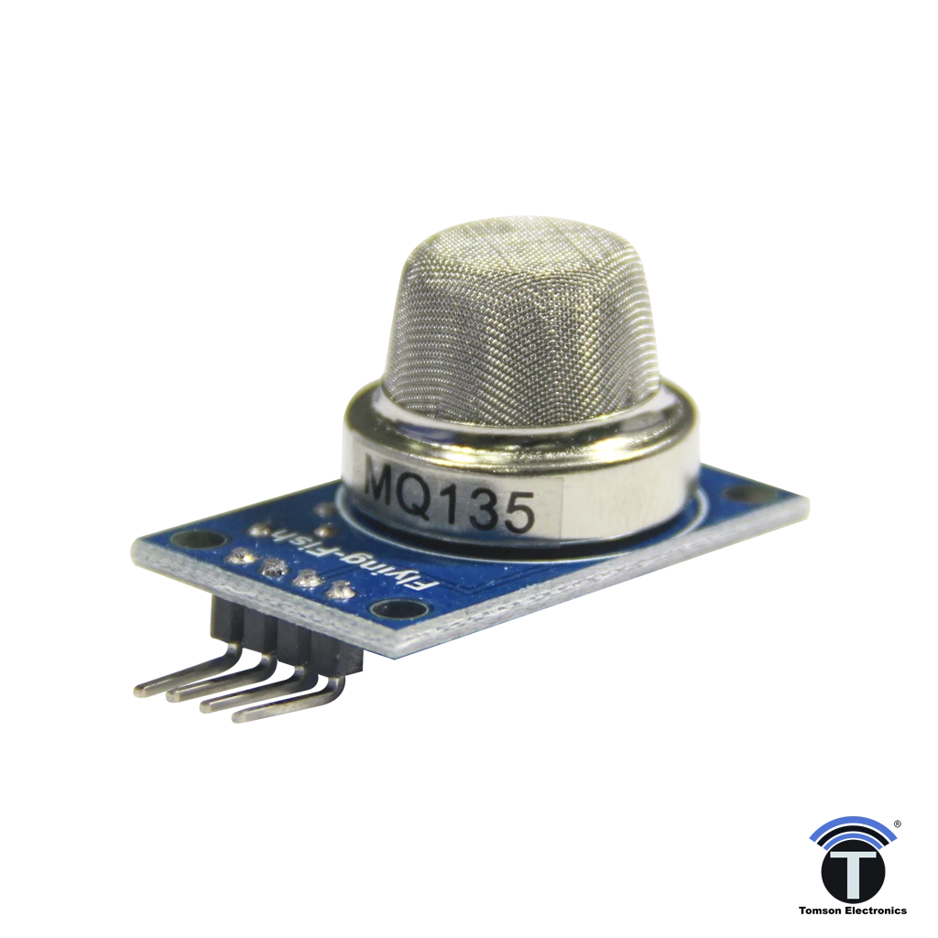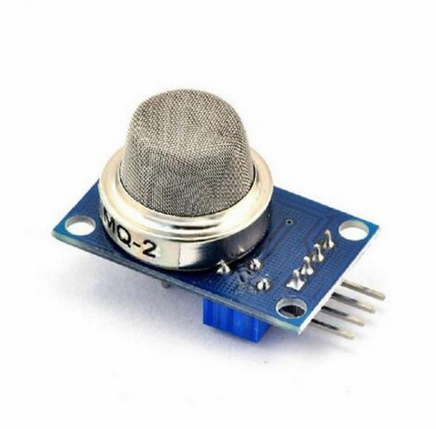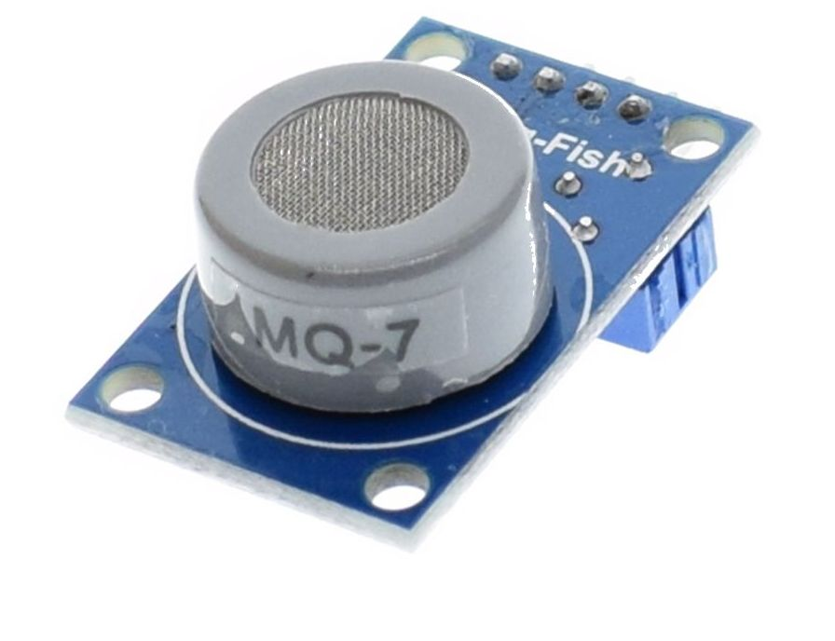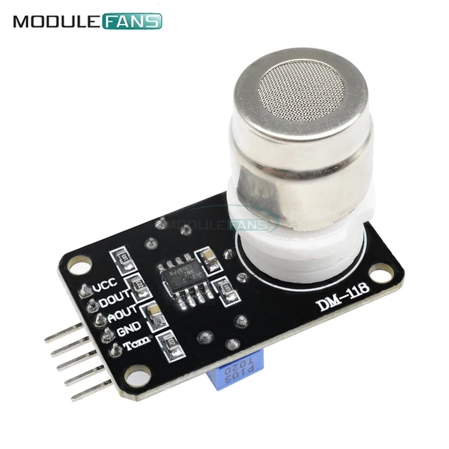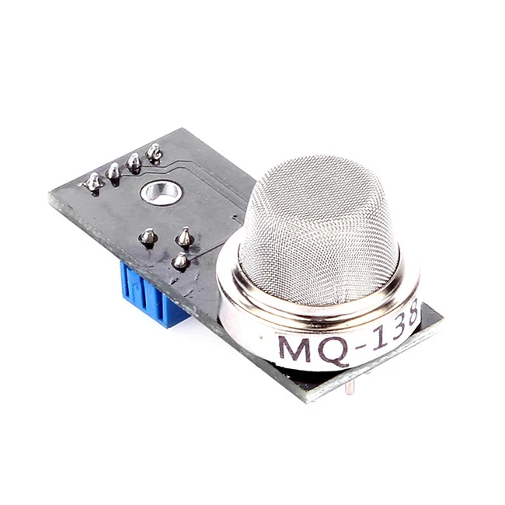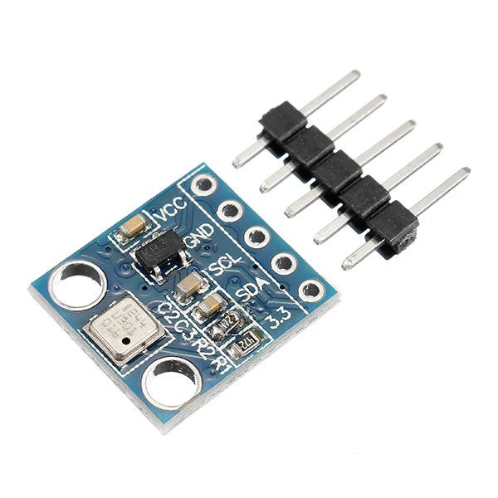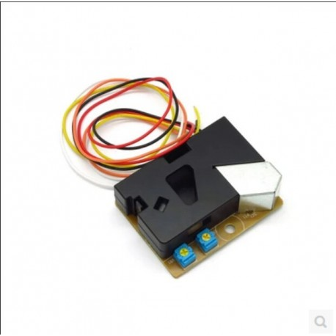

**Arduino Uno r3**

This is mainly used to read the electrical output from the sensors and control the working of the sensors in a periodic manner.

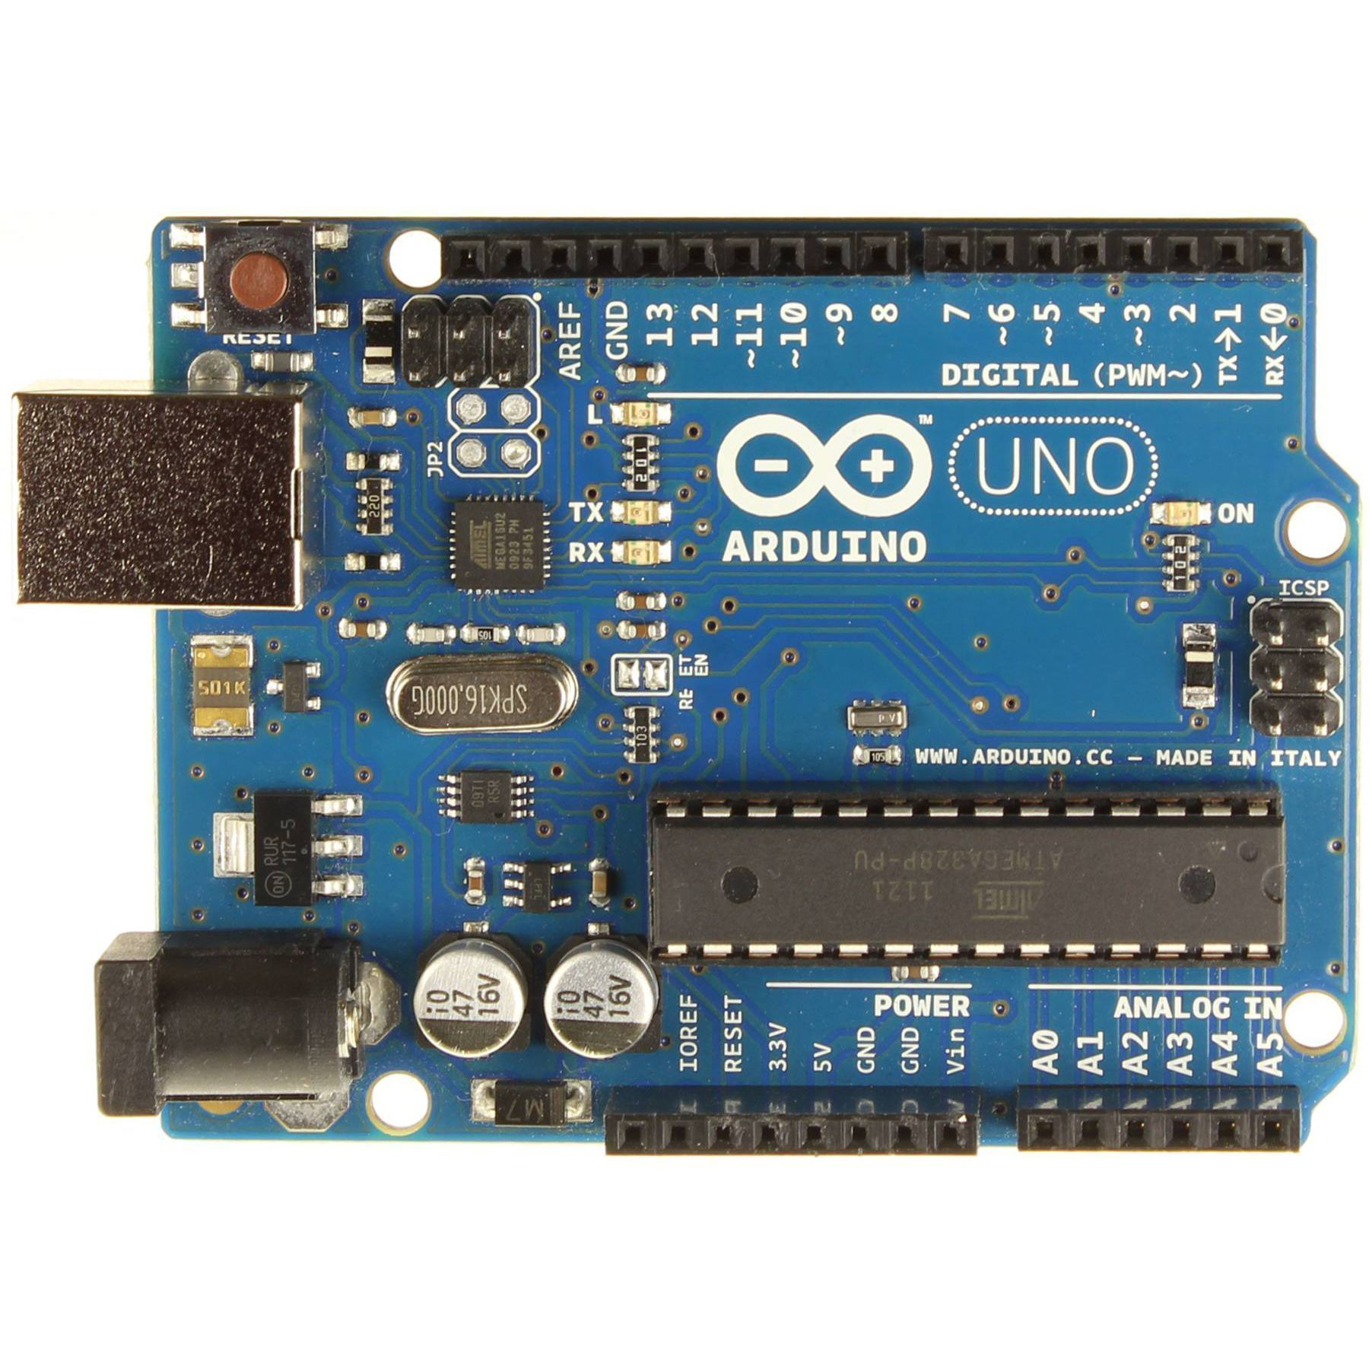

**Raspberry Pi 3B**

It is another vital component that is mainly used for storing the obtained data locally as well as in the cloud, and also used to achieve the programming aspects(i.e forecast algorithm) of the proposed model.

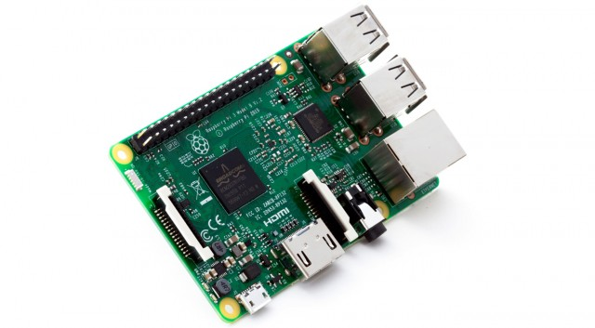

**Miscellaneous(Wires, Memory Card etc.)**

Wires are required to establish a working circuitry. Memory card is required to store the OS and data in the Raspberry Pi.